**Superstore Performance Review and Dashboard Insights**

Table of Contents

1.0 Introduction 3

1.2 Problem Statement 3

1.3 Opportunity and Strategic Solution 3

2.0 Theoretical Framework 4

2.1 Data Analytics Cycle 4

Problem Understanding and Definition 4

Data Acquisition and Preparation 5

Model Building 5

Data Analysis and Interpretation 5

Model Evaluation and Deployment 5

2.2 Application and Impact of Data Analytics and Business Intelligence to International Businesses 6

2.3 The Business Intelligence Framework in the Retail Sector 7

Organization Dimensions 7

Technological Dimensions 7

Environmental Dimensions 7

Procedural Dimensions 7

3.0 Data Analysis and Interpretations 8

3.1 Superstore Dashboard Insights 8

KPIs Showing Total Sales, Total Profit, Total Orders and Total Number of Customers 10

Bar chart showing Top 5 customers by sales, profits and orders 10

Doughnut Chart for Sales, Profit and Orders by Segment 11

Area Chart for sales, profit and orders 11

Map Chart for sales, profit and orders by location 12

Heat Map showing Top 5 sub categories by sales, profit and orders 12

Pie chart showing ship mode distribution for sales, profits and orders 13

4.1 Recommendations 13

4.2 Conclusion 14

# 1.0 Introduction

In today's data-driven business environment, organizations are increasingly leveraging Business Intelligence (BI) and data analytics as strategic tools to enhance decision-making, operational efficiency, and competitive advantage. This report examines the application of business intelligence and analytics within the consumer retail sector, known as Superstore, with the help of the dataset spanning from 2019 to 2020. The store specializes in multi-category shopping, offering a wide range of products, including office supplies, furniture, and technology, to individual customers, home offices, and corporate clients. This research employs data visualization and analytical technologies (Power BI) to explore the conversion of the store's structured data into actionable insights that will inform strategic planning and operational improvements. It will also investigate the data analytics cycle and the importance of BI systems in uncovering hidden patterns.

# 1.2 Problem Statement

Despite its extensive market presence, the store encounters significant challenges in optimizing profitability, retaining customers, and addressing regional sales differences. Conventional reporting techniques have demonstrated their insufficiency in delivering the detailed insights necessary to properly tackle these difficulties. The integration of Business Intelligence (BI) and data analytics serves as a strategic remedy, facilitating the conversion of raw data into actionable insights (Saleh, 2025).

# 1.3 Opportunity and Strategic Solution

This integration offers significant potential for Superstore to improve its operational efficiency and strategic decision-making. Utilizing BI tools, the store can convert extensive raw data into actionable insights, facilitating a comprehensive understanding of customer behaviours, market trends, and internal operations. This data-centric methodology enables informed decision-making, facilitating focused marketing tactics, optimized inventory management, and improved consumer interaction. The dashboard will provide answers to the following business questions.

* Key performance indicators based on sales, profits, orders, and end users
* The geographical performance of the store
* The classification of products and their profitability
* The segmentation of customers and their profitability
* The preference for shipping modes
* The pattern of performance over time

# 2.0 Theoretical Framework

## 2.1 Data Analytics Cycle

The data analytics lifecycle is a structured, iterative framework that assists organizations in the transformation of raw data into actionable insights. This guarantees that data analysis endeavours are executed in a systematic manner to extract the maximum value and are in alignment with business objectives (Tiwari, 2024). The cycle includes six critical phases.

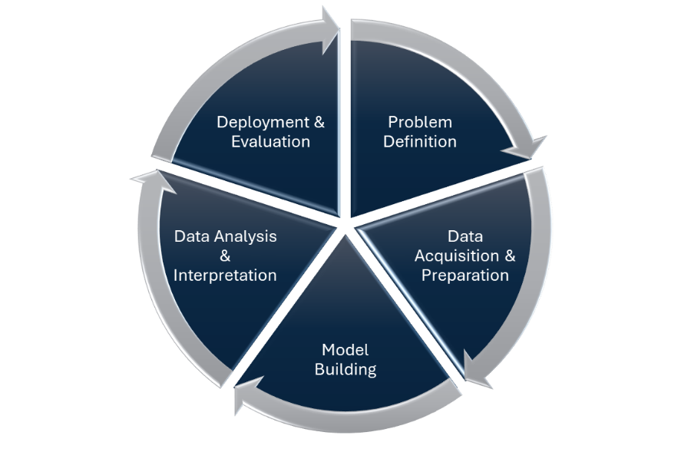

**Figure 2.1**

### Problem Understanding and Definition

This initial phase involves clearly articulating the business problem or opportunity that data analysis seeks to address. It requires collaboration with stakeholders to comprehend the context, define objectives, and establish the scope of the analysis. A well-defined problem statement sets the direction for the entire analytics endeavour (Khan et al., 2023).

### Data Acquisition and Preparation

During this phase, relevant data is gathered from several sources, including internal databases, external datasets, or real-time data streams. The collected data is subsequently cleaned and preprocessed to guarantee its quality and appropriateness for analysis. This process is called Exploratory Data Analysis (EDA), and this stage is essential as the precision of the analysis is significantly dependent upon the quality of the data (Day et al., 2019).

### Model Building

Here, analytical models are constructed utilizing suitable statistical or machine learning methodologies to reveal patterns and correlations within the data. The selection of modelling techniques is contingent upon the characteristics of the problem and the type of data at hand. This phase converts data into a format suitable for generating insights (Davies, 2024).

### Data Analysis and Interpretation

The developed models are being applied to the data to examine outcomes and interpret findings within the framework of the business challenge. This phase encompasses fitting the data to the model, model validation, and the extraction of insights to guide decision-making (Santra et al., 2021).

### Model Evaluation and Deployment

Upon extraction of insights, the models are assessed for accuracy, relevance, and practical applicability. This entails evaluating their performance using real-world data and ensuring alignment with the objectives. Upon validation, the models are implemented in operational systems or decision-support tools, including dashboards. Ongoing monitoring is crucial after deployment to assess the models' effectiveness and guarantee their alignment with shifting business conditions or emerging data trends (Rangineni et al., 2023).

## 2.2 Application and Impact of Data Analytics and Business Intelligence to International Businesses

The integration of data analytics and big data into business processes is essential for improving decision-making and fostering innovation. Sharda et al. (2018) highlight the significance of Decision Support Systems (DSS) in aiding semi-structured and unstructured decision-making processes. These systems utilize data, analytical models, and intuitive interfaces to assist managers in deciphering complex information, therefore facilitating informed strategic and operational decisions.

Paul et al. (2014) introduce the Business Analysis Service Framework, which shows the importance of aligning business analysis services with organizational objectives. This framework advocates for a structured approach to business analysis, ensuring that data analytics initiatives are closely tied to business needs and outcomes.

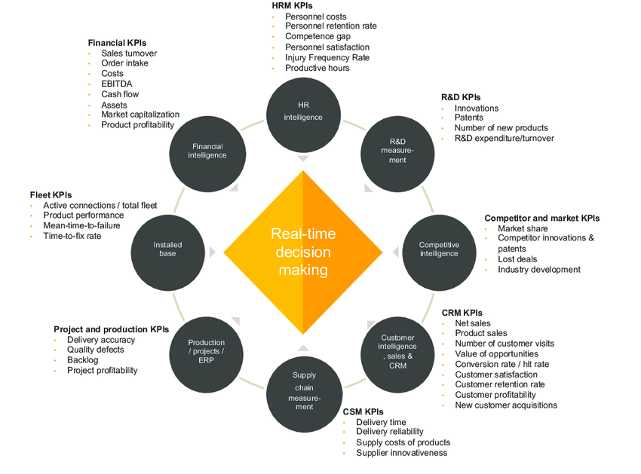

Figure 2.2: The use of the Business Intelligence framework in different industries

Kopanakis et al. (2016) examine the theory of Data-Driven Innovation (DDI), emphasizing the role of big data analytics as a catalyst for innovation in organizations. The study provides proof of the substantial influence of big data in promoting innovation-driven business strategies, resulting in enhanced performance. It contends that the capacity to collect and evaluate extensive datasets enables companies to get insights that propel product and process advancements. Müller et al. (2018) also conducted an econometric analysis examining the correlation between big data analytics and organizational success. These findings indicate a positive relationship, showing that companies that invest in big data analytics often experience improved performance outcomes, which can be further customized to address their specific business challenges.

## 2.3 The Business Intelligence Framework in the Retail Sector

The retail sector is undergoing a significant transformation due to the incorporation of Business Intelligence (BI) technologies, enabling businesses to convert extensive datasets into practical insights. A comprehensive theoretical framework for Business Intelligence in retail includes several essential dimensions: organizational, technological, environmental, and procedural (Bradlo et al., 2017).

### Organization Dimensions

This relates to the internal framework, culture, and assets of a retail business. Successful BI deployment necessitates a culture that prioritizes data-driven decision-making, comprehensive staff training, and the alignment of BI projects with strategic goals.

### Technological Dimensions

The technology infrastructure provides the foundation of BI systems. This encompasses data warehousing, analytical instruments, and real-time data processing functionalities.

### Environmental Dimensions

External factors, including market trends, consumer behaviour, and competitive dynamics, impact BI strategies.

### Procedural Dimensions

This involves the methodologies and procedures for data gathering, analysis, and dissemination of insights. Establishing procedures guarantees uniformity and dependability in data management, essential for accurate decision-making.

Integrating all these dimensions, this framework serves as a comprehensive guide for retailers aiming to leverage BI for enhanced performance (Amira & Ghailan, 2023).

# 3.0 Data Analysis and Interpretations

The dashboard developed for Superstore functions as an effective decision-support instrument, aimed at displaying essential business metrics in a transparent and dynamic manner. It allows business professionals, irrespective of technical expertise, to analyze performance trends, customer behaviour, and sales dynamics in real time, hence facilitating data-driven decision-making across departments of the store.

## 3.1 Superstore Dashboard Insights

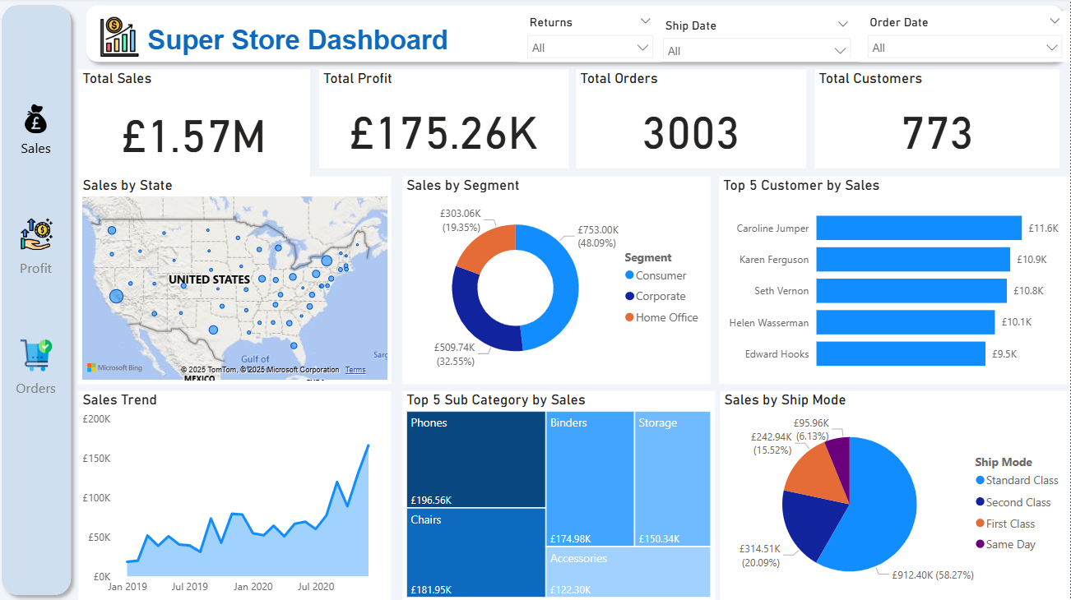

**Figure 3.1 Superstore Sales Dashboard**

At the top of the dashboard, the figure being displayed are KPIs metrics tracking the Total Sales, Total Profit, and Total Customers Served between 2019 and 2020. These give a high-level summary of how the business is performing during any selected period. Just above these figures, there are simple filter tools. These tools help to narrow down the data based on Order Date, Ship Date, or whether the item was returned or not. When these filters are applied, the entire dashboard updates instantly to reflect the selection.

On the left side of the dashboard, there’s a view switcher that lets viewer choose between different focus areas such as sales, profit, or orders. Currently, the sales view is active, and it includes several helpful visual insights such as sales by state, segment, top customers, sales trend, sales by subcategories and by shipping mode.

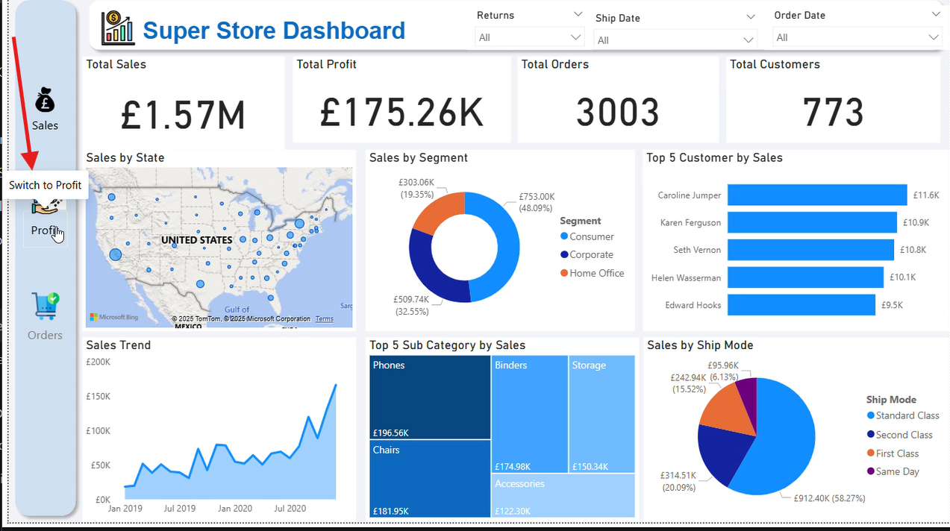

**Figure 3.2 Superstore Dashboard Profit View**

To switch to a different view, viewer can simply use the icon on the left side of the dashboard by clicking on it and pressing “Control” then “OK”, the dashboard updates to show the Profit View. This can also be done to switch to the Orders view. In the Profits view, viewer can see how profit is performing across different areas such as by state, customer segment, product sub-categories, shipping modes, profit trend over time and the top 5 most profitable customers.

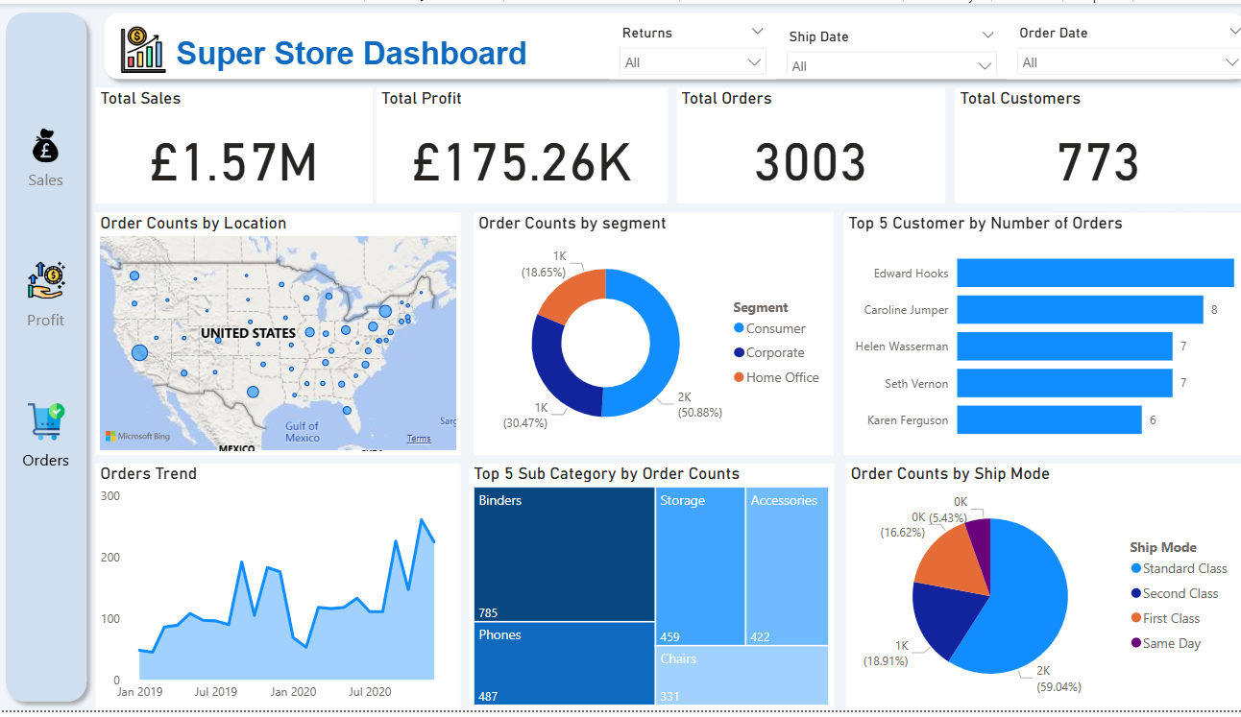

**Figure 3.3 Superstore Dashboard Orders View**

### KPIs Showing Total Sales, Total Profit, Total Orders and Total Number of Customers

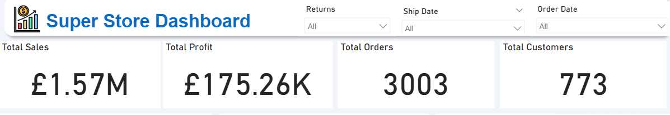

**Figure 3.4**

Total Sales represents 2019–2020 consumer purchasing revenue. Total Profits show the store's financial performance. Total Orders shows the cumulative number of transactions, regardless of quantity or value, while Total Customers shows the unique count of customers who made at least one purchase, providing a comprehensive view of consumer engagement and reach over time. One main justification for these metrics is how important they are for organization success and planning. Monitoring these figures regularly can help understand customer behavioural patterns over time for retention and demand projection.

### Bar chart showing Top 5 customers by sales, profits and orders

**Figure 3.5**

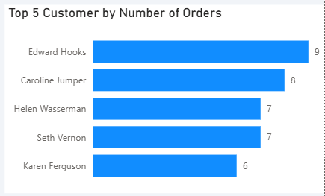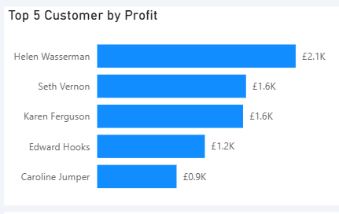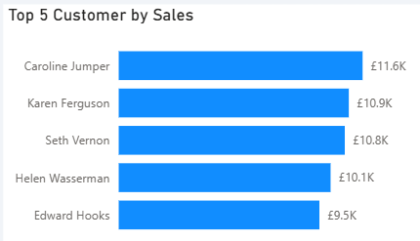

This shows that the customer with the highest revenue ranks fifth in profit, yet the customer with the highest profit ranks second in sales. According to order volume, the most loyal customer ranks fourth in profit and fifth in sales. The variations show that large sales do not always mean good profitability or loyalty. Business professionals can use this insight to determine who spends the most and delivers the greatest value. It analyzes purchase behaviour, refines client segmentation, and prioritizes retention for volume and margin-advantaged consumers to boost profitability.

### Doughnut Chart for Sales, Profit and Orders by Segment

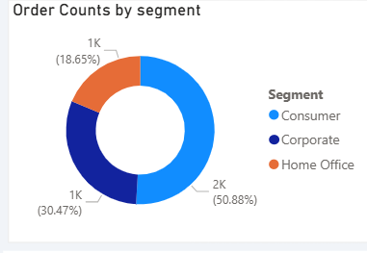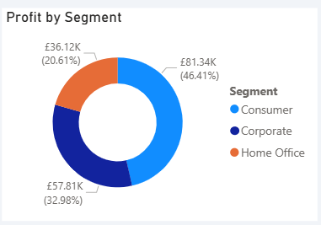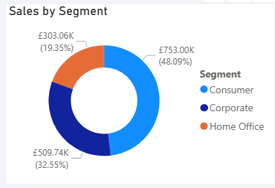

**Figure 3.6**

Sales, Profit, and Orders are divided across Consumer, Corporate, and Home Office clients in the donut chart. In all three categories, Consumer have the highest, followed by Corporate and Home Office. With consumers dominating, this indicates engagement and profitability. This insight can help business professionals focus marketing, promotions, and product offerings on this high-performing segment while also assessing ways to boost engagement and profitability from the Corporate and Home Office segments.

### Area Chart for sales, profit and orders

**Figure 3.7**

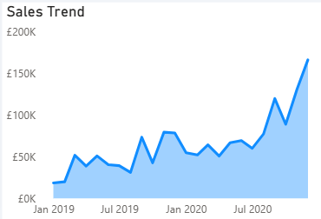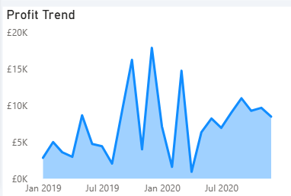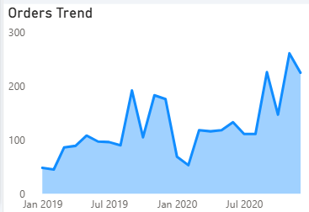

The area chart shows the 2019–2020 trend progression. Sales consistently rise, showing revenue growth. However, profit shows three peak periods, suggesting that high-performing months, especially between late 2019 and early 2020, influenced profitability. Orders follow a trajectory that closely mirrors sales, validating the premise that increasing consumer activity contributed to revenue growth. This helps business professionals evaluate performance levels and important shifts, enabling better demand planning, inventory, and marketing tactics during peak periods.

### Map Chart for sales, profit and orders by location

**Figure 3.8**

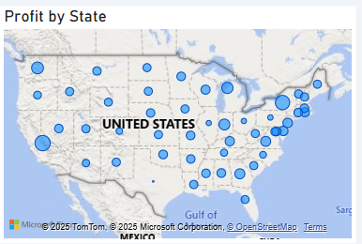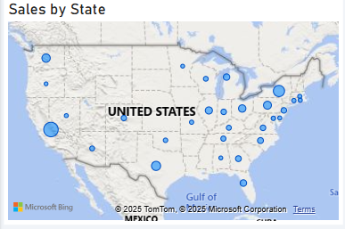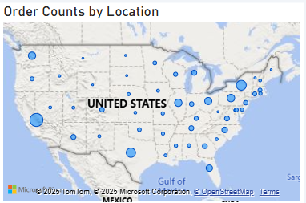

The map chart shows U.S. sales, profit, and order distribution. Sales and orders are scarcely distributed, reflecting nationwide customer activity. Profit is concentrated in the east, showing that despite identical or fewer orders, some regions are more profitable. This insight aids business professionals in identifying high-value markets, focusing supply chain, and customer engagement strategies in regions with higher ROI.

### Heat Map showing Top 5 sub categories by sales, profit and orders

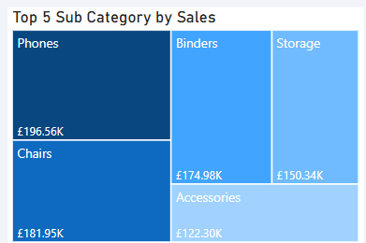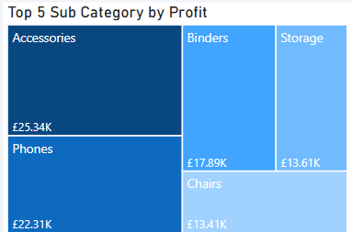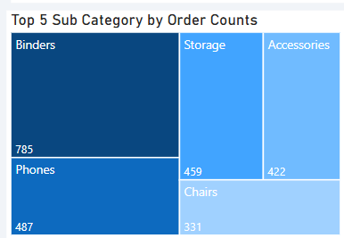

**Figure 3.9**

Mobile phones are the highest-selling items, followed by chairs, binders, storage solutions, and accessories. The profit distribution indicates that Accessories lead, then Phones, implying that certain popular items may lack profitability. Binders are the most often ordered category, notwithstanding their poor sales and profit margins. This highlights multidimensional performance assessment and can assist professionals in enhancing product strategy, including boosting marketing for high-margin products like accessories and adjusting pricing or cost strategies for high-volume, low-profit Binders.

### Pie chart showing ship mode distribution for sales, profits and orders

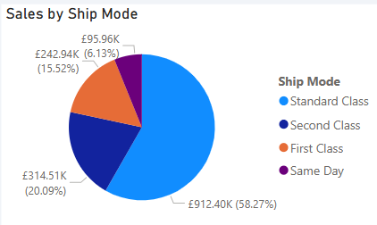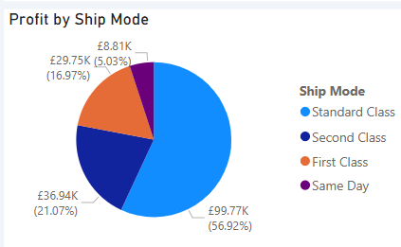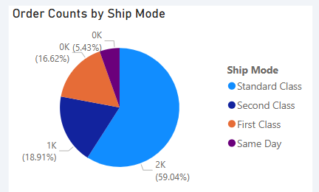

**Figure 3.10**

The pie chart shows the contributions of various shipping modes for total sales, profits, and order volumes. Standard Class and Second Class are the predominant shipping methods across all three measures, indicating that the majority of customers favour these options, perhaps due to a balance between cost and arrival time. This pattern indicates that the majority of revenue and earnings are associated with these shipping methods. This is essential in logistics planning and cost optimization and by analyzing the predominant shipping methods utilized by customers, organizations can optimize operations, negotiate more favourable shipping rates, or investigate strategies to promote the adoption of premium shipping choices.

# 4.1 Recommendations

**1. Integrate CRM Systems for Unified, Real-Time Insights**

To enhance the dashboard's efficacy, the store should combine it with its current Customer Relationship Management solutions. This integration can guarantee that all departments have access to uniform, real-time data, promoting unified decision-making (Graham, 2025).

**2. Establish Cross-Functional Business Intelligence (BI) Teams**

Forming cross-functional BI teams involving individuals from IT, sales, marketing, and operations departments helps drive more comprehensive insights. These teams would utilize varied knowledge to establish pertinent KPIs, create tailored dashboards, and analyze data proficiently. Cross-functional collaboration has been shown to accelerate innovation and enhance customer satisfaction by fostering a collaborative environment where expertise is shared (Inbaragja, 2013).

**3. Implement Advanced Customer Segmentation Techniques**

Utilize sophisticated analytical frameworks such as Recency, Frequency, Monetary (RFM) analysis and Customer Lifetime Value (CLTV) to effectively segment customers. RFM analysis clarifies customer behaviour by assessing the recency and frequency of purchases, as well as expenditure levels (FocusKPI, 2025). CLTV forecasts the cumulative value a customer contributes throughout their entire engagement with the business (Okay, 2022). Employing these models facilitates targeted marketing strategies and optimal resource allocation (Dash & Mishra, 2012).

**4. Promote User Adoption Through Structured Training Programs**

To facilitate extensive utilization of the dashboard, Superstore should implement systematic training initiatives throughout all tiers of the company. Training programs significantly influence the adoption of a new BI tool, as individuals will not utilize the tool if they lack knowledge of its operation. Comprehensive training enables staff to effectively comprehend and utilize the dashboard, resulting in enhanced decision-making and the cultivation of a data-driven culture (Young, 2019).

# 4.2 Conclusion

In conclusion, the performance review and insights generated from this dashboard analysis highlight the critical role of data-driven decision-making in resolving operational inefficiencies and identifying strategic opportunities. By transforming raw sales, customer, and operational data into actionable insights through Power BI, Superstore’s management can now better understand performance disparities across geographies, product categories, customer segments, and time periods.

The findings reveal key performance gaps such as high-revenue sectors with low profitability and regional inconsistencies in market outcomes, which call for more targeted business strategies. Trend analysis also highlights seasonal peaks, especially in Q4 2020, which can inform smarter marketing initiatives, inventory planning, and resource allocation.

One of the most valuable takeaways is the insight into product strategy. While items like chairs and phones generate high sales volumes, they underperform in terms of profitability. Conversely, categories like accessories, though accounting for fewer sales, contribute significantly to profit margins. This calls for a reassessment of product focus and pricing strategies to better align sales efforts with profitability goals.

# References

amira, A. T., & Ghailan, M. M. (2023). Theoretical Framework for Business Intelligence Adoption. *Theoretical Framework for Business Intelligence Adoption*. https://doi.org/10.2139/ssrn.4503831

Bradlo, E., Gangwar, M., Kolapelle, P., & Voleti, S. (2017, March). *(PDF) The Role of Big Data and Predictive Analytics in Retailing*. ResearchGate. https://www.researchgate.net/publication/315471275_The_Role_of_Big_Data_and_Predictive_Analytics_in_Retailing

Dash, P., & Mishra, S. (2012, December). *Developing RFM Model for Customer Segmentation in Retail Industry December 2012*. https://www.researchgate.net/publication/256041900_Developing_RFM_Model_for_Customer_Segmentation_in_Retail_Industry

Davies, G. (2024). *Data lifecycle: The 8 stages and who is involved | KNIME*. KNIME. https://www.knime.com/blog/the-data-lifecycle?

Day, R., Shoop, A., Jaiswal, A., Zhang, J., & Rundensteiner, E. (2019). Automated Process for Data Acquisition, Analysis, and Preprocessing. *The International Conference on Data Science and Intelligent Systems*. https://www.researchgate.net/publication/334279924_Automated_Process_for_Data_Acquisition_Analysis_and_Preprocessing

FocusKPI. (2025, March 18). *In today’s retail and e-commerce landscape, segmentation is the secret sauce that separates fast-growing brands from those struggling to keep up. Why? Because segmentation unlocks the ability to tailor your marketing and messaging to specific groups of customers—dramatically boosting engagement, ret*. Linkedin.com. https://www.linkedin.com/pulse/how-segmentation-fuels-growth-ltv-rfm-cohort-analysis-retail-dey9e/

Graham, F. (2025, May 6). *Zurich Insurance’s new CRM is like Spotify for insurance agents — and it could improve customer service*. Business Insider Africa. https://africa.businessinsider.com/news/zurich-insurances-new-crm-is-like-spotify-for-insurance-agents-and-it-could-improve/dvr95tv

Inbaragja, D. S. (2013, November 15). *The Rise of Cross-Functional Teams in the Retail and Consumer Goods Sector*. Www.linkedin.com. https://www.linkedin.com/pulse/rise-cross-functional-teams-retail-consumer-goods-james-md-mba-zrhqc/

Ioannis Kopanakis, Konstantinos Vassakis, & Mastorakis, G. (2016). Big Data in Data-driven Innovation: The Impact in Enterprises’ Performance. *11th Management of Innovative Business, Education & Support Systems International Conference*. https://www.researchgate.net/publication/305906536_Big_Data_in_Data-driven_Innovation_The_Impact_in_Enterprises

Khan, J. A., Raman, A. M., Sambamoorthy, N., & Prashanth, K. C. (2023). *Research Methodology (Methods, Approaches And Techniques)*. SAN International Scientific Publications. https://doi.org/10.59646/rmmethods/040

Müller, O., Fay, M., & vom Brocke, J. (2018). The Effect of Big Data and Analytics on Firm Performance: An Econometric Analysis Considering Industry Characteristics. *Journal of Management Information Systems*, *35*(2), 488–509. https://doi.org/10.1080/07421222.2018.1451955

Okay, H. (2022, January 2). *RFM and CLTV to Know Your Customers Better - Hakan Okay - Medium*. Medium. https://medium.com/%40hokay18/using-rfm-and-cltv-for-customer-segmentation-dd16084c66df

Paul, D., Cadle, J., Eva, M., Rollason, C., & Hunsley, J. (2014, September 23). *📖[PDF] Business Analysis by Debra Paul | Perlego*. Www.perlego.com. https://www.perlego.com/book/1637438/business-analysis-pdf

Pauwels, K., Ambler, T., Clark, B. H., LaPointe, P., Reibstein, D., Skiera, B., Wierenga, B., & Wiesel, T. (2009). Dashboards as a Service. *Journal of Service Research*, *12*(2), 175–189. https://doi.org/10.1177/1094670509344213

Rangineni, S., Bhanushali, A., Suryadevara, M., & Peddireddy, K. (2023). A Review on Enhancing Data Quality for Optimal Data Analytics Performance. *International Journal of Computer Sciences and Engineering*, *11*(10), 51–58.

RGIS. (2023, November 17). *Getting the Most From Inventory Data Using the RGIS Dashboard*. RGIS. https://www.rgis.com/case-study/getting-the-most-from-inventory-data-using-the-rgis-dashboard/

Saleh, I. M. (2025). Strategic Integration of Big Data Analytics and Business Intelligence for Enhancing Supply Chain Resilience in SMEs. *Journal of Information Systems Engineering and Management*, *10*(11s), 381–397. https://doi.org/10.52783/jisem.v10i11s.1600

Santra, A., Komar, K., Bhowmick, S., & Chakravarthy, S. (2021). From Base Data To Knowledge Discovery -- A Life Cycle Approach -- Using Multilayer Networks. *ArXiv (Cornell University)*. https://doi.org/10.48550/arxiv.2105.11410

Sharda, R., Delen, D., & Turban, E. (2018). *Sharda, Analytics, Data Science, & Artificial Intelligence: Systems for Decision Support, 11th Global Edition*. Www.pearson.com. https://www.pearson.com/se/Nordics-Higher-Education/subject-catalogue/information-systems/Sharda-Analytics-Data-Science-Artificial-Intelligence-Systems-for-Decision-Support-Global-Edition-11th-Edition.html

Tiwari, V. (2024). Role of Data Analytics in Business Decision Making. *Knowledgeable Research a Multidisciplinary Journal*, *3*(01), 18–27. researchgate. https://doi.org/10.57067/0zr57x43

Wamba, S. F., Gunasekaran, A., Akter, S., Ren, S. J., Dubey, R., & Childe, S. J. (2017). Big data analytics and firm performance: Effects of dynamic capabilities. *Journal of Business Research*, *70*(1), 356–365. https://www.sciencedirect.com/science/article/pii/S0148296316304969

Young, B. (2019, December 9). *4 Ways to Improve the Adoption of Dashboards within your Organization*. Medium. https://medium.com/@brandon.young0/4-ways-to-improve-the-adoption-of-dashboards-within-your-organization-a43dd2a98701